08/07/2025

Dear Dr. Smith,

I am referring this patient for your expert opinion.

Patient presents with symptoms requiring specialist evaluation.

Thank you for your consideration.

Sincerely,  
Dr. Test

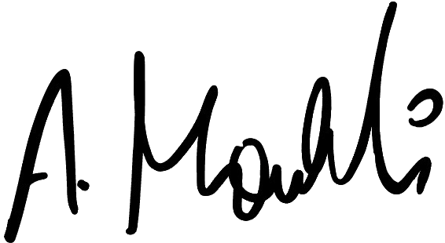

Dr. Ahmad Moukli M.D, MSc, MRCGP